Thoughts on Membership Levels
Draft memo

October 10, 2022

The Governance Committee has produced this document to describe the next edition of our membership program. The committee would appreciate feedback from the Finance Committee and the Marketing Committee.
The original membership program consisted of one option: Professional membership for $100. There are two types of membership: Free and paid. The new program will have levels of membership based on company size.

Professional Member vs. Registered Guest
The Governance Committee reported in July that they strongly believed that even to use the word member for individuals who have not joined and paid something was not in the best interest of NSITP or paying members. They recommended changing the title to Registered Guest.

The New Membership Program
The Governance Committee proposes the following membership program for discussion:

Registered Guest Free
- Available to self-designated MSP, VAR, Vendor, Educator, Media, etc.
- Receive public email updates about the organization
- Can attend public meetings
- Understands the NSITSP code of ethics

Professional Member $125 or more
- Available to self-designated MSP, VAR, Vendor, Educator, Media, etc.
- This is an individual, who might be any person working in the IT industry
- Access to members-only information on the website such as: reports, files, membership directory and forums
- Access to training regarding ethics and industry best practices*
- Legislative updates and advocacy guidance*
- Attend public, private and committee meetings
- Can vote in NSITSP elections
- Listed in the Membership Directory
- Can serve on Committees
- Member to member communication
- Receive digital membership logo to use for website, business cards, etc.
- Adhere to the NSITSP code of ethics
*in development

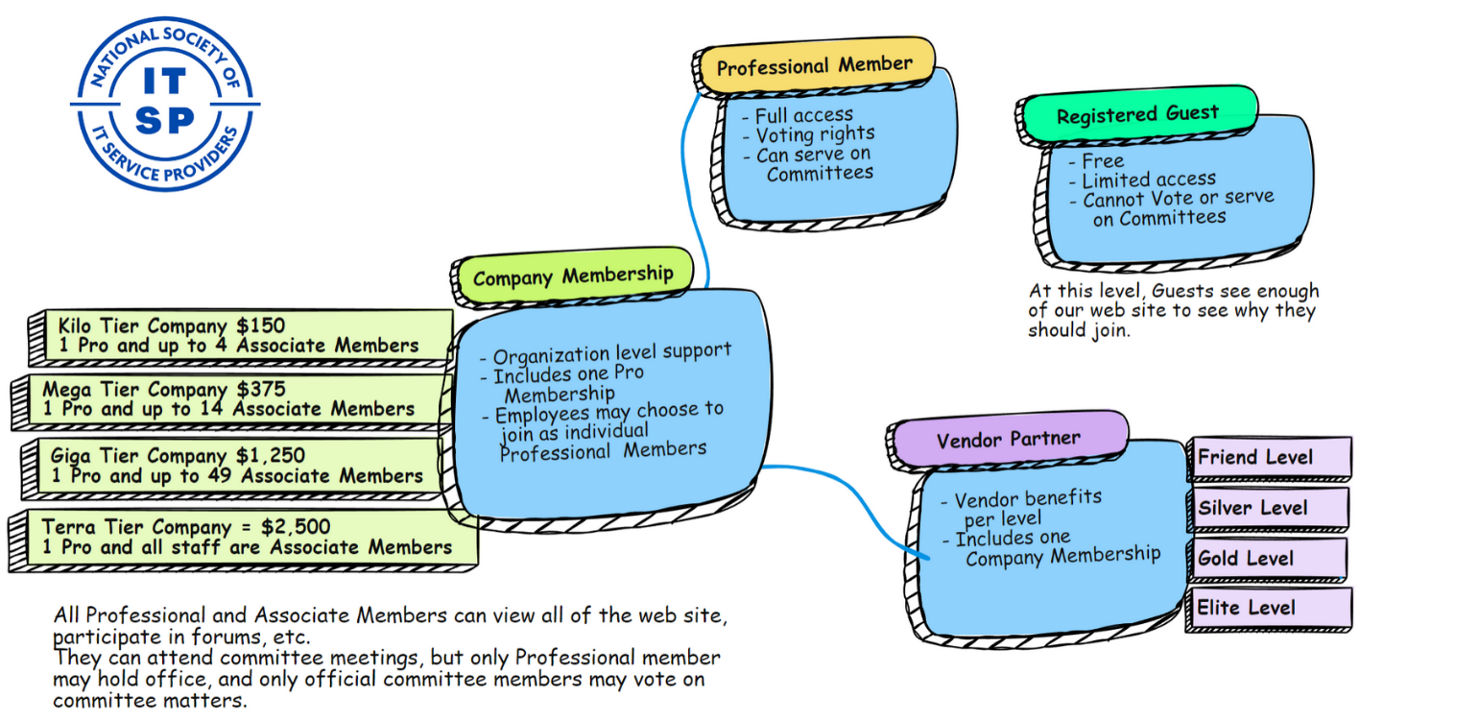

Company Membership
- Four tiers of member, based on company size. There is no distinction in benefits based on company size other than the number of Associate Members.
- The idea is that companies will self-select their level and pay a membership fee commensurate with the company size.
- Each company will have one paid, professional membership, to be designated during onboarding. This one member will be the only voting company member and may sit on committees and enjoy all the benefits of a full professional member.
- Other company employees will be Associate Members. Associate members have full access to the web site, including forums, meeting archives, etc. They do not have voting rights and cannot run for office. They can attend committee meetings as non-voting members. Whether or not a specific meeting is open to the general membership for attendance or participation in discussions is at the suffrage of the chair.

Vendor Partners (Note: The Vendor Partner Program is already in place)
- Each Vendor Partnership includes one Company Membership
- As a result, each Vendor Partner can designate one Professional member. All other employees maybe considered Associate members.

A note on Associate Membership. Associate members are basically all the employees of a member company. They may participate in forums and discussions. But only professional members may run for office, hold committee board positions, and vote in organization elections.

Any associate member is presumed to be an IT professional and may choose to join as an individual professional member, separate from the company that employs them.

